**NEAR EAST UNIVERSITY**

**Faculty of Engineering**

**Department of Electrical and Electronic Engineering**

**Generator Backup System for a Critical Load**

**EE 402 – Components List**

**Student:Asem Abdou (20193554)**

**Instructor:  Assist. Prof. Dr. Parvaneh Esmaili**

**Nicosia – 2020**

# Table of Contents

Table of Contents 2

1. INTRODUCTION 3

2. COMPONENTS USED 3

2.1 DIESEL ENGINE GOVERNOR (Khaled Dia) 3

2.2 THREE SYNCHRONOUS DIESEL-POWERED GENERATORS WITH 600 KW CAPACITY FOR EACH ONE. (Majd AbuNimeh) 4

2.3 Synchronous motor (Ahmed Ali) 4

2.4 TRANSFORMER (Khaled Dia and Amin Aqel) 5

2.5 CIRCUIT BREAKER (Abdelrahman Mahmoud) 5

2.6 Three phase to ground Fault (Abdelrahman Mahmoud) 5

2.7 Three Phase Source (Majd AbuNimeh) 5

2.8 Automatic Transfer Switch (Abdelrahman Mahmoud) 6

2.9 GSM (Asem Abdou) 6

2.10 System computer interface(Asem Abdou) 6

# INTRODUCTION

To list the components and the methods of any system you need to know the goal or the aim of the system. So the main goal for this project is to provide a backup power system using generators so when the mains fail, the generators supply the power to the load and distribute the load equally among themselves, In case one or more of the generators fails or becomes operational again, the working generators shall redo the load balancing. When the mains power becomes available, the generators shall stop.

# COMPONENTS USED

Here I am listing all the components that might be used in the whole project then I will indicate the components used by each member in the group.

## 2.1 DIESEL ENGINE GOVERNOR (Khaled Dia)

In power circuits there is a part called diesel engine generator governors, its function is controlling the diesel engine speed. This diesel engine must have a pre-set speed to meet the output specifications in the generator. If the speed of the engine is not right, the generator will not meet the required output specifications

Figure ‎2.1: Engine Generator Governo

## 2.2 THREE SYNCHRONOUS DIESEL-POWERED GENERATORS WITH 600 KW CAPACITY FOR EACH ONE. (Majd AbuNimeh)

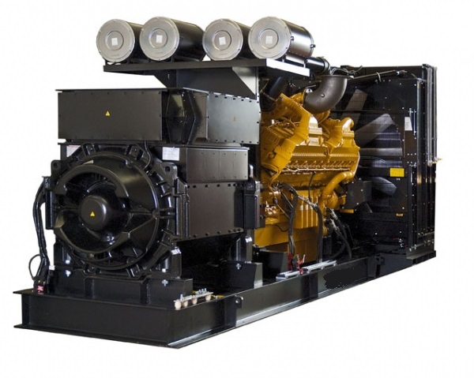

Figure ‎2.2: Diesel-Powered Generator

## 2.3 Synchronous motor (Ahmed Ali)

A synchronous electric motor is an AC motor in which, at steady state, the rotation of the shaft is synchronized with the frequency of the supply current; the rotation period is exactly equal to an integral number of AC cycles.

## 2.4 TRANSFORMER (Khaled Dia and Amin Aqel)

is to transform voltages, currents, and impedances to higher or lower values from one port to the other one so it is needed to balance the load before and after the fail in the mains

## 2.5 CIRCUIT BREAKER (Abdelrahman Mahmoud)

The circuit breaker is essential safety circuit in diesel generators to cut the power when the critical load is exceeded, using Simulink libraries and toolbox for simulation and design purpose, we can use the breaker shown in the figure

Figure ‎2.3: Circuit Breaker in Simulink power system toolbox

## Three phase to ground Fault (Abdelrahman Mahmoud)

It is simply a ground for the mains and the whole system.

## Three Phase Source (Majd AbuNimeh)

It represents the mains that supplies the facility with electricity.

## 2.8 Automatic Transfer Switch (Abdelrahman Mahmoud)

It is an essential component in the safety circuit , the main function of Automatic transfer switch in diesel backup generator systems is to redistribute the utility or the mains to the backup power system, and this happens after it detects the power failure automatically

Figure ‎2.4: Automatic Transfer switch

## 2.9 GSM (Asem Abdou)

## System computer interface(Asem Abdou)

To provide remote monitoring via cell and smart device capabilities for the generators.

**The components I am going to use in my task are listed below.**

By having an internet link to the generators, we can read the oil pressure, engine temperature, battery voltage, power output, diesel levels, engine run time and engine RPM.

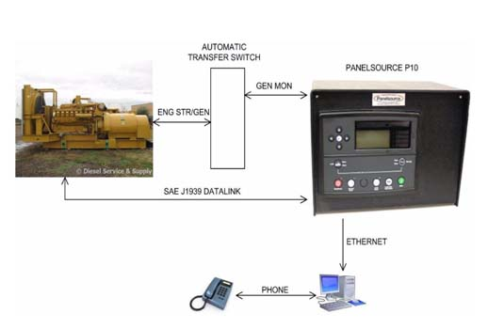

Figure2.9

1. GSM
2. System computer interface,

By having an internet link to the generators, we can read the oil pressure, engine temperature, battery voltage, power output, diesel levels, engine run time and engine RPM.